**Blazer FC**

**“Made by the students for the students”**

**Admins**

* Arkadeep Das (adas3)
* Giri Mallena (smalle23)
* Nikhil M (nmuthyal)
* Rohit Vanamula (vanamula)
* Rohan Sirsilla (sirsilla)
* Hrishikesh Vikram (hvikram)

Contents

Introduction 1

Abstract: 1

Admin Access: 1

User Access: 1

Implementation and Technologies 2

Designing the front end- 2

Designing the back end- 2

Results 3

Admin side: 3

User side: 11

Future Works 17

References 18

# Introduction

## Abstract:

The idea of the project is to develop an application for the sports club where users can create an account and book slots to play different games. Likewise, the Sports club administrators will be able to add new features to the application like adding new slots or games or deleting slots for different games, updating the slots, lookup for available games, and lookup for already booked games and their corresponding slots.

This web application will have two access types, one user access, and the other admin access. Both the user and admin must register and then must select the type of access to get entry inside the application.

### Admin Access:

In this sports club app, the admin needs to register the first post which he or she will be able to add slots for specific games and add their corresponding price. Admin is also empowered to delete slots for a particular game and will also be able to update slot timing and price for a particular game. The admin can look up the list of available games, their corresponding slots, and their prices. He or she can also have a look at the already booked slots for different games.

### 

### User Access:

In this sports club app, when the user first needs to register post that user will be able to log in after selecting the type of access. Once the login is completed, the user will be directed to the games page, where the user will be able to view the schedule of the games. He can get information about all the available games, their respective available time slots, and the price associated with them. After checking the availability, the user can book slots by choosing the type of game and his or her desired timing slots. If the slots are available, the user can then only add those games and time slots to the cart page and pay for them to reserve it.

Apart from this, the user can have a look at the gallery which contains collections of images of all the available sports.

The user can also read about the Sports Club by clicking on the About Us.

The user can also reach out to the admin and write to the admin using Contact.

# Implementation and Technologies

## Designing the front end-

For our static pages we have used HTML(Hypertext Markup Language) to design our basic structure and have used CSS(Cascading Style Sheets) and Bootstrap for animating and styling it

We have used HTML to design the basic structure because its quite interactive, responsive and easy to implement for designing web pages.

We have used CSS for majority of the styling operation, it is free, fast and helps a lot in maintenance and optimization. Bootstrap is a opensource CSS framework developed by twitter which is quite adaptable. Bootstraps helps in removing redundancy in code while styling a web page.

We have used Javascript for scripting the front end to interact with various front end elements.

## Designing the back end-

We have used python programming language and flask as the framework for interacting with the front and connecting the front end with the backend. The flask framework is compatible with most search engines. It has development server and debugger.

We have used sqlite3 as our database as it is compatible with python, it is a freeware, and supports most of the SQL standards.

# Results

## Admin side:

Initial registration page

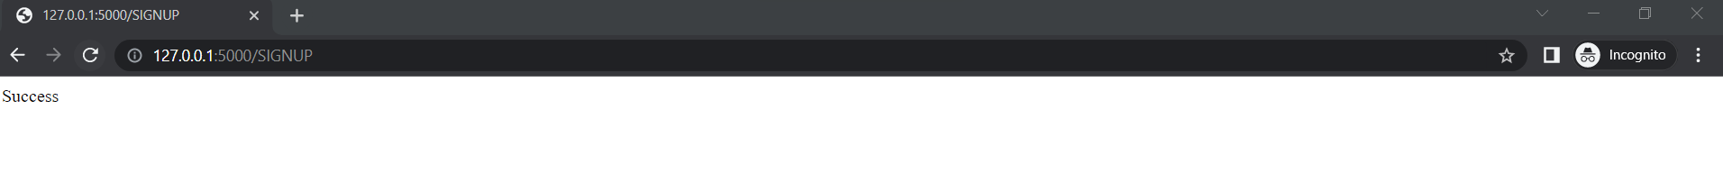

The admin puts his or her details to register first.



Admin cant register using the same username which is already been used previously.

Post registering the admin can log in to the application.

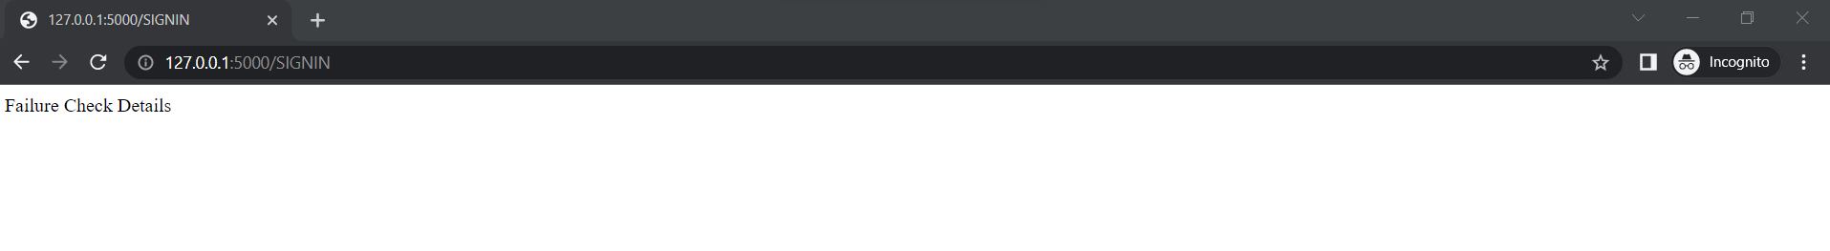

If he put the wrong sign in details he won’t be able to enter the application.

After successfully logging in the admin will be directed to the home page.

Post the admin can get inside the Admin System after clicking on the Slots button.

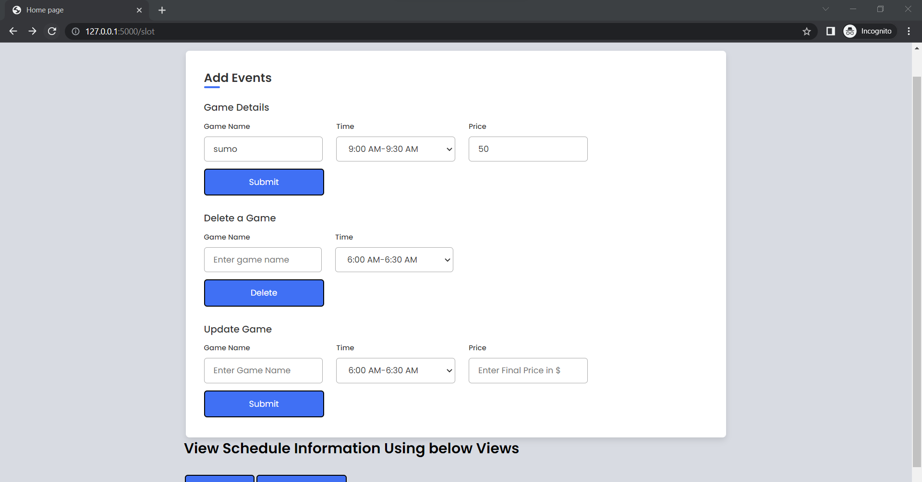



Here the admin can add slots and prices for different games.

The admin can remove slots for a particular game.

The admin can also check all the slots of different games and prices by clicking on the List All Schedules button.

The admin can also view already booked slots by clicking on the List All Schedules.

The Admin can also Update game time and price.

Before update

After update

If the game is not registered already and if the admin tries to update it will shoot an error.

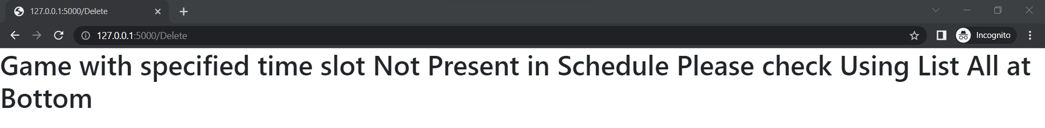

Same when the Admin tries to delete a game which is not present it will shoot an error.

## User side:

Initial registration page

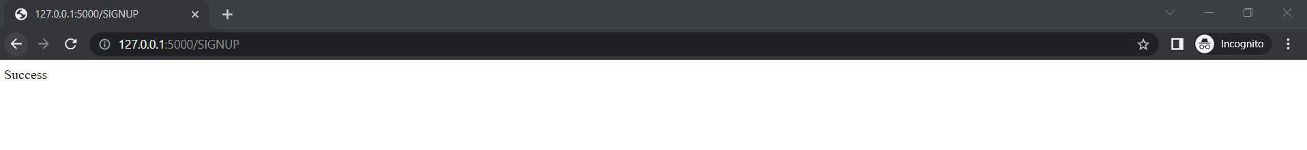

Success registration.

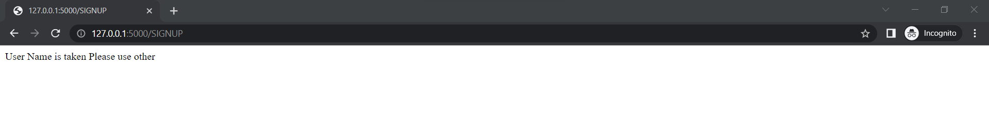

If the user uses an already taken username it will show some error.

After putting in the correct credentials the user can get logged in.

The user cant get access inside the application if incorrect login details provided.

This is what the home page for users looks like.

After clicking the events button the user can see the schedule of all the available sports with their corresponding price. Here the user can choose his or her favourite sport and book the available slots and can book the same by clicking the book button.

If the slots are available for that particular game it will show successfully booked otherwise it will show no time slots for this sport at this time.

After booking all the slots for all the desired games the user can click on the cart page to see all the selected games in the cart and can pay the total amount in order to get the schedules booked.

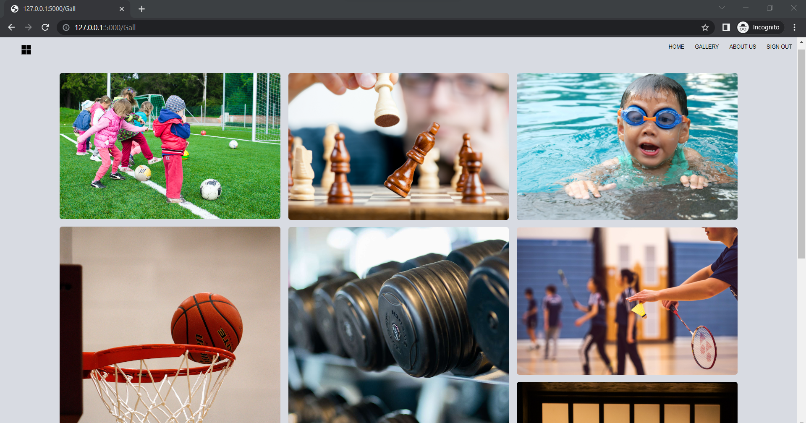

The user can also visit the gallery which stores the image collection of all the available games and activities in the sports club.

The user can also visit the About Us page to take a look at the details of the sports club.

The user can also visit the contact us page to write something and post valuable feedback to the admin team.

# 

# Future Works

This Sports Club Web Application is now only restricted to web applications, but it can be further developed into a mobile application where people can easily download it through the apple store and android store.

Now there are only image galleries, and some people prefer videos over static images, we can further work and upload videos and live coaching sessions soon, to draw customers.

A separate schedule can be added where customers can hire one-to-one training sessions with expert trainers.

Premium membership can be added to enable premium members to get more facilities like slots at a discounted rate, dietary consultation, and buy merchandise from Blazer Apparel Store.

# 

# References

* <https://www.sliderrevolution.com/resources/bootstrap-login-form/>
* <https://mdbootstrap.com/docs/standard/extended/login/>
* <https://us.niemvuilaptrinh.com/article/31-login-pages-in-html-for-website>
* <https://icons.getbootstrap.com/icons/cart/>
* <https://getbootstrap.com/docs/5.2/examples/>
* <https://www.w3schools.com/css/css_table.asp>
* [www.w3schools.com/](http://www.w3schools.com/)
* <https://greensock.com/gsap/>
* <https://getbootstrap.com/docs/5.2/getting-started/introduction/>
* <https://unpkg.com/>
* <https://www.includehelp.com/code-snippets/display-alert-message-on-button-click-event.aspx>
* https://fonts.googleapis.com/
* <https://blog.miguelgrinberg.com/post/the-flask-mega-tutorial-part-iii-web-forms-legacy/page/4>
* https://fonts.gstatic.com/
* <https://michaelabrahamsen.com/posts/form-validation-with-flask-meld/>
* https://www.pexels.com/
* <https://flask.palletsprojects.com/en/2.1.x/debugging/>
* <https://www.w3schools.com/html/html_form_elements.asp>
* <https://www.reddit.com/r/flask/comments/nwu9no/flask_post_request_for_update_sqlite_table/>